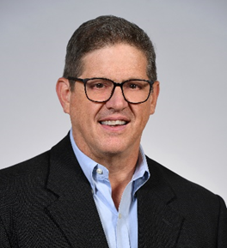  Scott G. Smith  Director of Client Services  Herbein Human Capital |  HR Consulting  484.465.1206  sgsmith@herbein.com | Scott Smith is a seasoned human capital strategist with over 25 years of executive leadership experience, primarily in the manufacturing sector. He holds a B.S. in Marketing with a minor in Economics from Penn State University, is SHRM-SCP certified, and completed executive education in strategic leadership at Lehigh University. Dedicated to continuous growth, Scott actively engages in peer-based leadership forums, including Vistage International and The High Center.  As Director of Client Services at Herbein Human Capital, Scott works closely with organizations to drive value through strategic human capital initiatives. His core focus areas include organizational design - ensuring the right structure and roles are in place; talent acquisition - securing high-impact leadership talent; and advancing leadership and organizational effectiveness - to retain and inspire. He brings a pragmatic, results-oriented approach to aligning people with strategy, ensuring the right individuals are in the right roles, and are doing the right things to create value, manage risk, and enhance sustainability.  Outside of work, Scott enjoys outdoor activities, family, and serving others through community involvement. | Focused On  - Strategic Planning - Vision building and Strategic Execution  - Organizational Effectiveness - Organizational Design, Culture, and Leadership Excellence  - Talent Acquisition – Executive Search and Talent Acquisition Strategies  Education & Certifications  - Pennsylvania State University (BS, Marketing and minor in Economics)  - Lehigh University - Manufacturing Leadership Institute, Strategic Leadership for Growth and Innovation  - Society for Human Resource Management, SHRM-SCP  Involvement  - The High Center – Sponsor and Peer Group co-facilitator.  - Society for Human Resource Management (SHRM) – Professional Development  - Hospice / Mental Health America

